

***Imdosa pump and pit maintenance and servicing***

Imdosa P/L provides Pump Maintenance & Pump Servicing for a large range of corporate, industrial, body corporate and building management companies.

Preventative pump maintenance is an essential part of any well managed pump system, ensuring all parts are working efficiently and reducing the life cycle costs of the system.

Every pump requires maintenance to ensure reliable and efficient operation. An un-serviced pump system can become a costly asset, experiencing premature failures that can damage both the system and potentially the surrounding areas. A periodical pump service will ensure optimum performance is being achieved. Our trained on the road pump technicians will work through check lists to confirm the system is in optimum working order, cleaning the systems and replacing perishable parts where necessary.

Imdosa can provide Periodical Pump Service contracts for individual systems or complete building sites with multiple pump systems, general contracts run on a 3, 6 or 12 month servicing schedule dependant on the system and application.

For any of your needs please contact us on: *(03) 9739 5195*

Or via email: *Info@imdosa.com.au*

We offer the best in customer service and competitive pricing in all aspects of

* 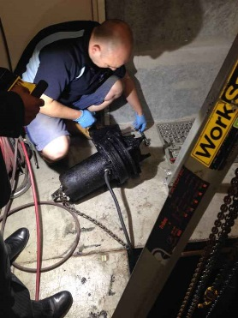Pump installation
* Pump service
* Pump repairs
* New pump sales
* Pit repairs
* Pit maintenance

***Technician providing routine service to submersible sewage pump***

Imdosa provides Pump Servicing to:

* 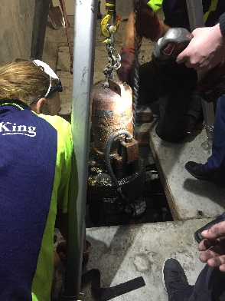Body Corporates - Commercial & Residential
* Schools
* Commercial Buildings
* Age Care Facilities
* Hospitals
* Recreation Centres
* Office Lunch Rooms
* Restaurants & Commercial Kitchens
* Municipal Plants
* Industry & Warehousing

***Removal of submersible stormwater pump***

* Domestic

Imdosa also offers pit cleaning and maintenance service for all types of pits, weather that be

* Sewage
* Stormwater
* Graywater
* Blackwater

We have the latest water jetting system to provide a non-disruptive and fast clean for all pits, as well as clearing blockages in pipes.

